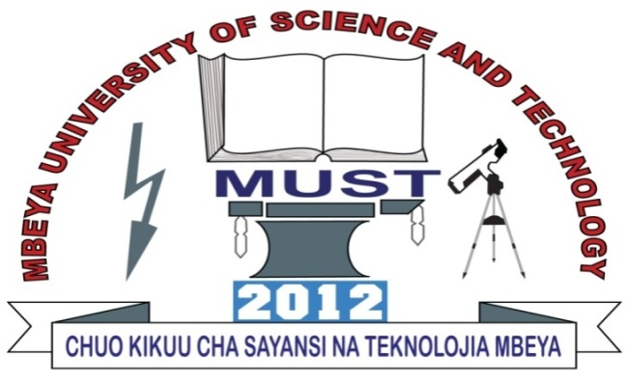
MBEYA UNIVERSITY OF SCIENCE AND TECHNOLOG

COURSE: BACHELOR OF ENGINEERING IN TELECOMMUNICATION SYSTEMS.
MODULE NAME: FUNDAMENTAL OF ELECTRONICS.
MODULE CODE: ET 8107.
NAME OF INSTRUCTOR: MZEE SIKO.
LEVEL: UQF 8 FIRST YEAR
TASK: GROUP ASSIGNMENT
ACADEMIC YEAR: 2022/2023
GROUP NO: 06
NAMES OF PARTICIPANTS
NO | NAME | REG NO | CA NO | SIGNATURE
1 | PAULO JOHN KAPEMBE | 22100934300
2 | BRIAN. P. MAKUA | 221009343400
3 | SEBASTIAN R MWANILWA | 22100934340052
4 | JOHN STANLEY MWALONGO | 221009343400
5 | NURUEL GOODLUCK SHAYO | 221009343400
6 | MWAJUMA CHECK RASHID | 221009343400
7 | KELVIN JOSEPH NGOWA
8 | LISIA VITUS TUNDUMA
9 | ELIUD DAUD MWANGUNULE | 221009343400
10 | MSAMILE BRAYAN ASENGA | 221009343400
11 | KHAIRATH SHAABAN HAJI | 221009343400
A semiconductor is the material which has an electrical conductivity value falling between that of conductor such as copper, and that of an insulator.
The most used semiconductor materials are silicon, Germanium, and Gallium arsenide.
Of these three germanium was one of the earliest semiconductor material used. Germanium has four valence electrons.
The number of valence electrons in a semiconductor material determine its conductivity.
While an important step on evolution of semiconductor materials, germanium has largely fallen into disuse in favor of the current king of semiconductor materials-SILICON.
Now days silicon is the most used semiconductor material and here are some reasons why silicon is the most used semiconductor material.
- After carbon, silicon is the most abundant element on the earth.
- Silicon is the chemical found in both sand and glass. It is the second most abundant element in the Earth’s crust. The abundance of silicon makes it inexpensive and easy to acquire.
- Silicon melts at higher temperature than germanium.
- Silicon melts at 1414 degrees Celsius in comparison to germanium which melts at 938.3 degrees Celsius.
- Extraction, purification and crystallization process for silicon are both efficient and economical.
Gallium arsenide is the second most common semiconductor in use today . unlike silicon and germanium, gallium arsenide is the compound and not an element, and is made by combining gallium with its three valence electrons, with arsenic which have five valence electrons.
Eight valence electrons make gallium arsenide devices respond quickly to electric signals.
Gallium arsenide has some limitations, however: the compound is more difficult to manufacture and masses than silicon and chemicals used in gallium arsenide production are quite toxic.
Therefore silicon is the most used semiconductor material.

REFERENCES:
THE ART OF ELECTRONICS by Paul Horowitz.
PRACTICAL ELECTRONICS FOR INVENTORS by Paul Scherz.
Https://irds.ieee.org>topics>semiconductors.

